Aldermaston and Woolhampton Benefice News

**(the parishes of Aldermaston & Wasing, Beenham, Brimpton, Midgham and Woolhampton)**

# **Sunday 20th April 2025: Easter Sunday**

**Christ is risen. Alleluia!**

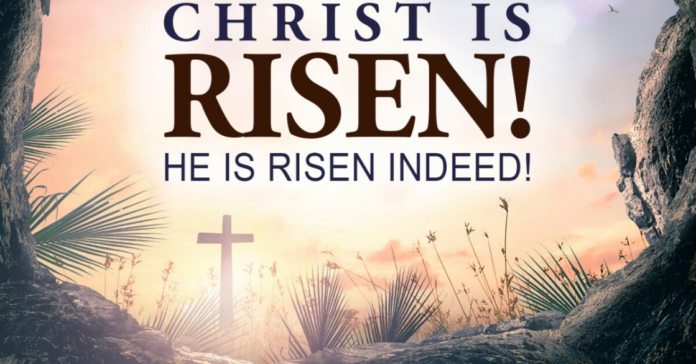.

**Services this Sunday**

St Mary’s, Aldermaston 10.45am Holy Communion

St Mary’s, Beenham 9.15am Holy Communion

St Peter’s, Brimpton 10.45am Holy Communion

St Matthew’s, Midgham 9.15am Holy Communion

St Peter’s, Woolhampton 10.45am Holy Communion

**Service next week: The Second Sunday of Easter**

St Peter’s, Woolhampton **10am** Benefice Communion

St Matthew’s, Midgham **5pm** Benefice Evensong

**Easter Greetings:** Derek, Katy and Jane wish you all a very peaceful, joyful and blessed Easter.

Jane will be on leave, apart from a couple of engagements, after Easter until Tuesday 29th April

**VE Day 80th Anniversary 8th May**

There will be a service of Commemoration of the 80th Anniversary of Victory in Europe at St Mary’s, Aldermaston on 8th May at 5.30pm to which you are all invited. The service will begin at the Lychgate.

**Benefice BBQ 7th June 12.30 – 2.30pm at the Longs’ Farm, Midgham** An opportunity for us to come together as a Benefice, meet old friends, make new. This is for everyone and we hope you can come. Tickets will be available soon. BBQ meat from Wasing Estate.

**Revision of Electoral Roll** A new electoral roll will be prepared this year. **People on the current roll are not automatically transferred. There** will be forms at the back of each of the churches.

You are entitled to be on the Electoral roll if you are baptised, over 16 and a member of the Church of England or a Church in communion with the Church of England, live in the parish **or** you habitually attend worship (habitually is defined as ‘on average once a month’) Please read the notes on the form. If you have any queries please speak to the Rector or the Electoral Roll Officer.

The deadline for submission for each of the churches is:

Aldermaston & Wasing 25th April

Brimpton **13th April – roll closed**

Midgham 28th April

Woolhampton 25th April

**Prayers and Pastoral Care** In the Benefice we seek to offer care for everyone in our churches and our communites, especially when they are in a difficult period in their lives. If you need to talk to a someone or would like a home visit, please contact the Rector on 0118 9712 891

You might just need to talk to someone in complete confidence about a personal or family crisis. We will always listen and help if we can. If you would like prayers included in our services on a Sunday for someone who is ill or in need, (providing the person is aware that they are being prayed for), has recently died or on the anniversary of their death, please do let me know. Revd Jane

We pray for those who are ill at this time and remember those who

have recently died and pray for those who grieve:

Prayers for Evelyn Weston (Brimpton) who is unwell at the moment.

Please print this newsletter and hand on to anyone you know who does not have internet access

**Rector:** The Rev’d Jane Manley jmanley.awb@gmail.com

01189712 891

**Assistant Priest**

The Revd Derek Spears [dspears.awb@gmail.com](mailto:dspears.awb@gmail.com)