Aldermaston and Woolhampton Benefice News

**(the parishes of Aldermaston & Wasing, Beenham, Brimpton, Midgham and Woolhampton)**

# **Sunday 23rd February: The Second Sunday before Lent**

**COLLECT** Almighty God, you have created the heavens and the earth and made us in your own image: teach us to discern your hand in all your works and your likeness in all your children; through Jesus Christ your Son our Lord, who with you and the Holy Spirit reigns supreme over all things, now and for ever.

**FIRST READING** *Revelation 4* This description of the endless worship of heaven emphasises the awesome holiness of God who, though wholly good, is almighty and eternal and to be feared.

**GOSPEL READING** *Luke 8.22–25*

Lake Galilee is surrounded by hills and is renowned for its sudden storms. Luke’s Gospel leaves us in no doubt: ‘they were in danger’. The disciples did not wake Jesus to say that they were a little concerned, but said ‘we are perishing!’ Jesus’s response leads to the punchline: ‘Who is this man?’

**POST COMMUNION PRAYER**  God our creator, by your gift the tree of life was set at the heart of the earthly paradise, and the bread of life at the heart of your Church: may we who have been nourished at your table on earth be transformed by the glory of the Saviour’s cross and enjoy the delights of eternity; through Jesus Christ our Lord.

**Services this Sunday**

St Matthew’s, Midgham 4pm Sung Evensong

St Peter’s, Woolhampton 10.45am Benefice Holy Communion

**Services on 2nd March: The Sunday next before Lent**

St Mary’s, Beenham 9.15am Holy Communion

St Peter’s, Brimpton 10.45am Holy Communion

St Matthew’s, Midgham 9.15am BCP Communion

St Nicholas, Wasing 10.45am Holy Communion

**Ash Wednesday 5th March 7pm** Service of Holy Communion and Imposition of Ashes at St Nicholas, Wasing

**Benefice Lent Course**

**A Lenten Journey with Paul**

**led by the Revd Dr Derek Spears**

An opportunity to look at different excerpts

from his letters.

The discussion group will be held on the following dates at 2pm 13th, 20th and 27th March, 3rd and 10th April

at 1 Church Lane, Brimpton

(each session is independent so you can dip in and out)

For further details please contact the Rector 01189 712 891

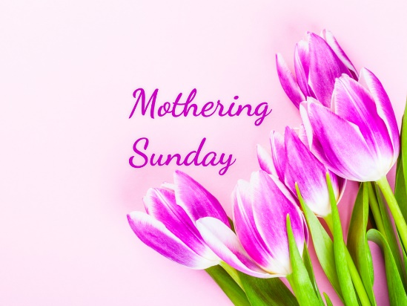**Mothering Sunday: 30th March 10am** Benefice Holy Communion at St Mary’s, Beenham. This is an opportunity to come together as a Benefice to celebrate the unity of our communities as the Body of Christ. Come along and worship in the beauty of St Mary’s Church.

**Prayers and Pastoral Care** In the Benefice we seek to offer care for everyone in our churches and our communites, especially when they are in a difficult period in their lives. If you need to talk to a someone or would like a home visit, please contact the Rector on 0118 9712 891

You might just need to talk to someone in complete confidence about a personal or family crisis. We will always listen and help if we can. If you would like prayers included in our services on a Sunday for someone who is ill or in need, (providing the person is aware that they are being prayed for), has recently died or on the anniversary of their death, please do let me know. Revd Jane

We pray for those who are ill at this time and remember those who

have recently died and pray for those who grieve

**Sheila Dunford**. Sheila’s funeral will be at West Berks Crematorium on 26th February at 2pm. Our prayers are with George and the family.

**Richard Hunt** We pray for Sue and the family. Richard’s funeral will be at St Peter’s Brimpton on Friday 7th March at 1.45pm

Please print this newsletter and hand on to anyone you know who does not have internet access

**Rector:** The Rev’d Jane Manley jmanley.awb@gmail.com

01189712 891

**Assistant Priest**

The Revd Derek Spears [dspears.awb@gmail.com](mailto:dspears.awb@gmail.com)