Aldermaston and Woolhampton Benefice News

**(the parishes of Aldermaston & Wasing, Beenham, Brimpton, Midgham and Woolhampton)**

# **Sunday 16th March: The Second Sunday of Lent**

**COLLECT** Almighty God, by the prayer and discipline of Lent may we enter into the mystery of Christ’s sufferings, and by following in his Way come to share in his glory; through Jesus Christ our Lord.

**FIRST READING** *Philippians 3.17―4.1* Paul tells his Philippian converts to examine their way of life in the light of the cross, and remain faithful to their heavenly hope. A good reading for Lent, contrasting an earthly and a heavenly focus and an exhortation to stand firm.

**GOSPEL READING** *Luke 13.31–35* The Jews believed that long ago God promised them through Abraham a peaceful and fruitful land. In time Jerusalem became its centre, and the Temple the focus of God’s presence for them. In this reading Jesus recalls a darker aspect of Jerusalem’s history.

**POST COMMUNION PRAYER** Almighty God, you see that we have no power of ourselves to help ourselves: keep us both outwardly in our bodies, and inwardly in our souls; that we may be defended from all adversities which may happen to the body, and from all evil thoughts which may assault and hurt the soul; through Jesus Christ our Lord.

**Services this Sunday**

St Mary’s, Aldermaston 10.45am Morning Praise

St Mary’s, Beenham 9.15am Morning Praise

St Peter’s, Brimpton 10.45am Morning Praise

St Matthew’s, Midgham 9.15am Holy Communion

St Peter’s, Woolhampton 10.45am Holy Communion

**Services on 23rd March: The Third Sunday of Lent**

St Peter’s, Woolhampton 10.45am Benefice Holy Communion

St Matthew’s Midgham 4pm Benefice Sung Evensong

**Benefice Lent Course**

**A Lenten Journey with Paul**

**led by the Revd Dr Derek Spears**

An opportunity to look at different excerpts

from his letters.

The discussion group will be held on the following dates at 2pm 13th, 20th and 27th March, 3rd and 10th April

at 1 Church Lane, Brimpton

(each session is independent so you can dip in and out)

For further details please contact the Rector 01189 712 89

**Do You Want To Fast This Lent?**

*(In the Words of Pope Francis…)*

* Fast from hurting words and say kind words.
* Fast from sadness and be filled with gratitude.
* Fast from anger and be filled with patience.
* Fast from pessimism and be filled with hope.
* Fast from worries and have trust in God.
* Fast from complaints and contemplate simplicity.
* Fast from pressures and be prayerful.
* Fast from bitterness and fill your hearts with joy.
* Fast from selfishness and be compassionate to others.
* Fast from grudges and be reconciled.
* Fast from words and be silent so you can listen.

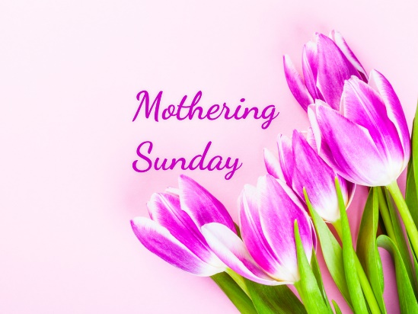**Mothering Sunday: 30th March 10am** Benefice Holy Communion at St Mary’s, Beenham. This is an opportunity to come together as a Benefice to celebrate the unity of our communities as the Body of Christ. Come along and worship in the beauty of St Mary’s Church.

**Good Friday Children’s Service 11am 18th April**

Help is needed for this service. If you would like to help with craft please let me know. Many thanks Rev Jane

**Revision of Electoral Roll** A new electoral roll will be prepared this year. **People on the current roll are not automatically transferred. There** will be forms at the back of each of the churches.

You are entitled to be on the Electoral roll if you are baptised, over 16 and a member of the Church of England or a Church in communion with the Church of England, live in the parish **or** you habitually attend worship (habitually is defined as ‘on average once a month’) Please read the notes on the form. If you have any queries please speak to the Rector or the Electoral Roll Officer.

The deadline for submission for each of the churches is:

Aldermaston & Wasing 25th April

Beenham 18th March

Brimpton 13th April

Midgham 28th April

Woolhampton 25th April

**Beenham: Please note that the Electoral roll closes this Tuesday 18th. No forms can be received after that date until after the APCM.**

**Prayers and Pastoral Care** In the Benefice we seek to offer care for everyone in our churches and our communites, especially when they are in a difficult period in their lives. If you need to talk to a someone or would like a home visit, please contact the Rector on 0118 9712 891

You might just need to talk to someone in complete confidence about a personal or family crisis. We will always listen and help if we can. If you would like prayers included in our services on a Sunday for someone who is ill or in need, (providing the person is aware that they are being prayed for), has recently died or on the anniversary of their death, please do let me know. Revd Jane

We pray for those who are ill at this time and remember those who

have recently died and pray for those who grieve:

Please print this newsletter and hand on to anyone you know who does not have internet access

**Rector:** The Rev’d Jane Manley jmanley.awb@gmail.com

01189712 891

**Assistant Priest**

The Revd Derek Spears [dspears.awb@gmail.com](mailto:dspears.awb@gmail.com)